

Semester Two Examination, 2021

Question/Answer booklet

MATHEMATICS  
SPECIALIST  
UNITS 1&2

Section One:  
Calculator-free

Teacher

Your name

|  |  |
| --- | --- |
| Number of additional answer booklets used (if applicable): |  |

## Time allowed for this section

Reading time before commencing work: five minutes

Working time: fifty minutes

## Materials required/recommended for this section

***To be provided by the supervisor***

This Question/Answer booklet

Formula sheet

***To be provided by the candidate***

Standard items: pens (blue/black preferred), pencils (including coloured), sharpener,  
correction fluid/tape, eraser, ruler, highlighters

Special items: nil

## Important note to candidates

No other items may be taken into the examination room. It is **your** responsibility to ensure that you do not have any unauthorised material. If you have any unauthorised material with you, hand it to the supervisor **before** reading any further.

## Structure of this paper

|  |  |  |  |  |  |
| --- | --- | --- | --- | --- | --- |
| Section | Number of questions available | Number of questions to be answered | Working time (minutes) | Marks available | Percentage of examination |
| Section One: Calculator-free | 8 | 8 | 50 | 50 | 35 |
| Section Two: Calculator-assumed | 13 | 13 | 100 | 92 | 65 |
|  | | |  | **Total** | 100 |

|  |  |  |
| --- | --- | --- |
| Markers use only | | |
| Question | Maximum | Mark |
| 1 | 5 |  |
| 2 | 6 |  |
| 3 | 6 |  |
| 4 | 6 |  |
| 5 | 6 |  |
| 6 | 7 |  |
| 7 | 6 |  |
| 8 | 8 |  |
| S1 Total | 50 |  |
| S1 Wt (×0.7) | 35% |  |
| S2 Wt | 65% |  |
| Total | 100% |  |

## Instructions to candidates

1. The rules for the conduct of examinations are detailed in the school handbook. Sitting this examination implies that you agree to abide by these rules.

2. Write your answers in this Question/Answer booklet preferably using a blue/black pen.  
Do not use erasable or gel pens.

3. You must be careful to confine your answers to the specific question asked and to follow any instructions that are specific to a particular question.

4. Show all your working clearly. Your working should be in sufficient detail to allow your answers to be checked readily and for marks to be awarded for reasoning. Incorrect answers given without supporting reasoning cannot be allocated any marks. For any question or part question worth more than two marks, valid working or justification is required to receive full marks. If you repeat any question, ensure that you cancel the answer you do not wish to have marked.

5. It is recommended that you do not use pencil, except in diagrams.

6. Supplementary pages for planning/continuing your answers to questions are provided at the end of this Question/Answer booklet. If you use these pages to continue an answer, indicate at the original answer where the answer is continued, i.e. give the page number.

7. The Formula sheet is not to be handed in with your Question/Answer booklet.

Section One: Calculator-free 35% (50 Marks)

This section has**eight** questions. Answer **all** questions. Write your answers in the spaces provided.

Working time: 50 minutes.

Question 1 (5 marks)

Let matrix $A=\left[\begin{matrix}-2 & 0 \\ 3 & 1\end{matrix}\right]$ and matrix $B=\left[\begin{matrix}2k-1 & 1 \\ 2 & k+1\end{matrix}\right]$, where $k$ is a constant.

(a) When $k=-1$, determine

(i) $AB$. (1 mark)

(ii) $3A-2B$. (2 marks)

(b) Determine the value(s) of $k$ if matrix $B$ is singular. (2 marks)

Question 2 (6 marks)

(a) Sketch the graph of $y=\sec\left(\begin{matrix}x \\ \overline{2}\end{matrix}\right)$ on the axes below for $0≤x≤4π$. (3 marks)

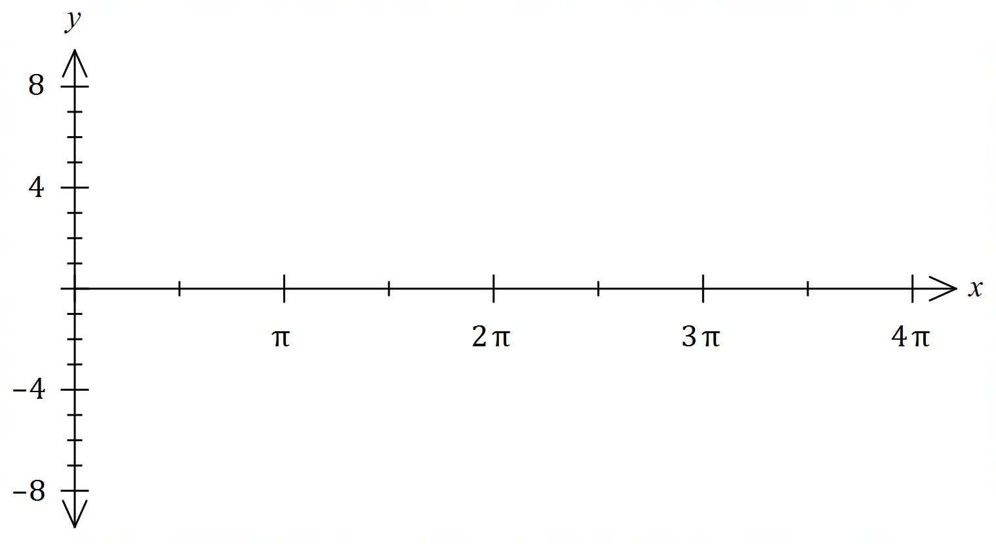

(b) Prove the identity $\operatorname{cosec}{2A}-\cot{2A}=\tan{A}$. (3 marks)

Question 3 (6 marks)

Let $z_{1}=\sqrt{5}+3i$ and $z_{2}=\sqrt{5}-i$. Determine each of the following in the form $a+bi$.

(a) $2z_{1}-z_{2}$. (1 mark)

(b) $i{\overline{z}}_{1}$. (1 mark)

(c) $z_{1}×z_{2}$. (2 marks)

(d) $z_{1}÷z_{2}$. (2 marks)

Question 4 (6 marks)

(a) Determine the value(s) of the constant $t$ given that $\left[\begin{matrix}-2 & 4 \\ t & 8\end{matrix}\right]\left[\begin{matrix}t \\ t\end{matrix}\right]=\left[\begin{matrix}2t \\ 33\end{matrix}\right]$. (2 marks)

(b) Determine $A^{-1}$ when $A=\left[\begin{matrix}7 & 3 \\ -2 & 2\end{matrix}\right]$. (2 marks)

(c) Show use of matrix methods to solve the following system of linear equations:

$$7x+3y-25=0 \\ 2y-2x+10=0$$

(2 marks)

Question 5 (6 marks)

(a) Using a product identity, or otherwise, evaluate $\sin\left(\begin{matrix}5π \\ \overline{12}\end{matrix}\right)+\sin\left(\begin{matrix}π \\ \overline{12}\end{matrix}\right)$. (3 marks)

(b) Solve the equation $2\sin^{2}{2x}=3\cos{2x}, 0≤x≤2π$. (3 marks)

Question 6 (7 marks)

(a) Determine all complex solutions to the equation $z^{2}-10z+27=0$. (2 marks)

(b) $z_{1}=-4-i$ is a solution to $f\left(z\right)=0$, where $f(z)$ is a real quadratic polynomial.

(i) State $z_{2}$, another solution to $f\left(z\right)=0$. (1 mark)

(ii) Let $z_{3}=z_{2}-z_{1}$. Plot and label $z_{1}, z_{2}$ and $z_{3}$ in the complex plane below. (2 marks)

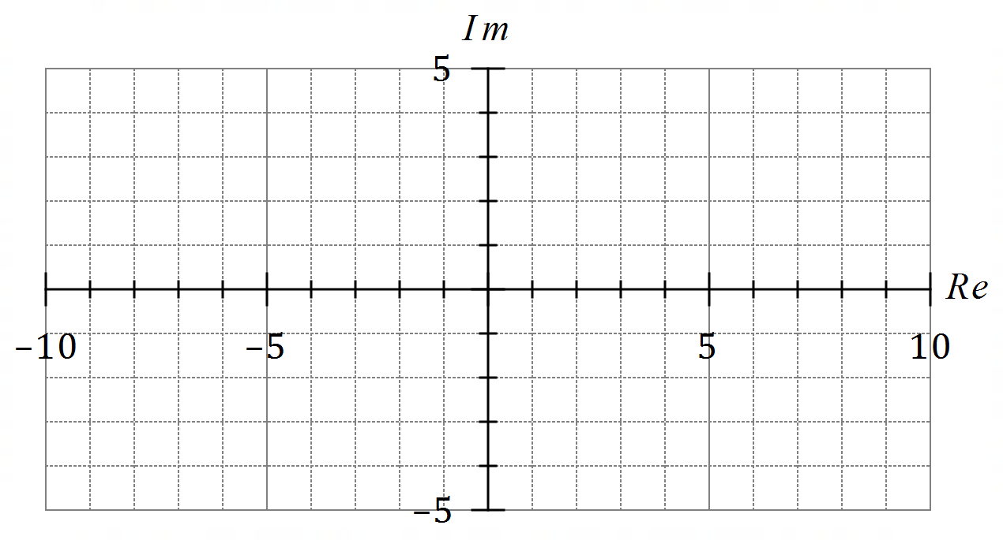

(iii) Determine $f(z)$, given that the coefficient of its $z^{2}$ term is $1$. (2 marks)

Question 7 (6 marks)

Use mathematical induction to prove that $2^{5n}-5^{n}$ is divisible by $9$ for all integers $n≥1$.

Question 8 (8 marks)

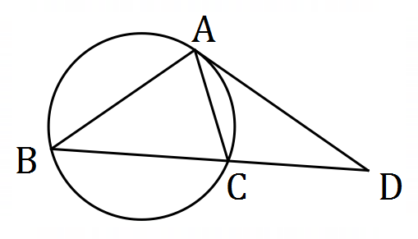(a) Points $A, B$ and $C$ lie on a circle.  
  
The tangent to the circle at $A$ intersects secant $BC$ at point $D$.

Prove that $AD^{2}=BD×CD$. (4 marks)

(b) Two unequal circles intersect at $P$ and $Q$. A common tangent touches one circle at $R$ and the other circle at $S$. $PQ$ produced intersects $RS$ at $X$. Prove that $X$ bisects $RS$. (4 marks)

Supplementary page

Question number: _________

© 2021 WA Exam Papers. Kennedy Baptist College has a non-exclusive licence to copy and communicate this document for non-commercial, educational use within the school. No other copying, communication or use is permitted without the express written permission of WA Exam Papers. SN245-181-1.